Information Systems Development and Organizational Viability: A Case Study of an Operational Division.

possible paper by one, two or three musketeers
INTRODUCTION.
Over recent years operational divisions in many kinds of organization have become ever more dependent upon their IT infrastructure. This dependence has give rise to many well documented issues. Operational divisions complain of being subject to technocratic rule by IT departments and seek to assert themselves. As a result new organizational practices such as outsourcing have become widespread. At the same time, there has been an acknowledged willingness amongst many operational departments to become more skilled in IS and IT issues so that they are less reliant upon ‘external’ sources of IT expertise. In turn this has lead some operational departments to become self sufficient; to be able to develop their own information strategies, to design their information systems and to implement IT.
This paper describes a case study of such self-sufficiency. It concerns the Sales team of ÔHeather Manufacturing SystemsÕ (HMS). Having already faced several years of market turbulence, and with ambitious growth and operational targets remaining, the team had radically and successfully revised their operational processes. As a natural extension of this they initiated their own IS development programme. This was undertaken independently of HMS’s central IT service which had a poor reputation amongst the operational divisions of the company.
The proposed IS strategy was given the go-ahead in early 1996 although it was not until early 1997 that the main design and development activities started. The project was given the name ÔWhole Europe Information System for SalesÕ (WEISS). Its focus is a groupware project using Lotus Notes to facilitate information sharing amongst the peripatetic sales engineers and the head office in England. The broad aim of WEISS is to improve the efficiency of processes operated by the Sales team. The scope of the project is as follows:
¥ Sales Order Processing;
¥ Sales Force Management;
¥ Management Information.
It was in undertaking this IS programme that the Sales team found it necessary to consider how empowered they really were. Despite notionally having considerable operational latitude, and being superficially autonomous with respect to IS strategy, the natural and dynamic pattern of interactions with other parts of the organisation served to impose limits on the freedom of the team. It was as if the very architecture of the organisation impinged upon their operational scope. As a result of this, as the IS development programme progressed, the teamÕs IS designers found that it became increasingly important to understand how the team worked with other teams, and when decisions were likely to have wider ramifications.
Two issues in particular have been raised.
¥ Delivery-time problems are causing frustration amongst customers.
Members of the Sales team find it difficult to obtain realistic estimates of delivery times from the Production team. The Production team are working at above full capacity and complain that Sales staff have unrealistic expectations of how quickly units can be built and despatched. The result of this is an increasing frustration amongst customers of HMS who now routinely find that the delivery dates for their orders are not kept. Faced with this difficult situation, there is growing concern that the issue be addressed from an IS perspective.
¥ Teams other than sales are now requesting functionality from WEISS.
As knowledge of WEISS grows throughout HMS, teams other than sales have requested that parts of the implementation be adapted to suit their purposes. For example, the Accounting team have requested that one field be added to an existing database in order that it might be useful to them also by allowing access information from a ÔPoint of InvoiceÕ field. The Engineering team have requested an additional facility (order tracking) arguing that it will be useful to them, to the Sales team and to the Accounting team in helping to keep track of the manufacture of products.
This interest in WEISS by other teams can be interpreted as evidence of the success of the project to date. Clearly the project is perceived in a positive light and other teams are keen to Ôbuy inÕ to it, albeit in a limited way. However, this raises issues about the scope of WEISS, who controls it and how, in the face of any conflict between different teams, issues can be resolved. For example, if in the future the Engineering team became dependent upon some aspect of WEISSÕs operation which the Sales team wanted to change, how would any conflict be resolved?
The position taken in this paper is that these issues can at some level be understood to be a consequence of the organizational design of HMS. Thus, whilst the designers of the WEISS system are notionally free to develop whatever systems the Sales team want, in practice they must consider the organisational constraints upon the Sales team itself.
The paper reports upon the insights gained by using the Viable System Model (VSM) (Beer, 1972; 1979; 1985) to model the HMS’s structure. It depicts the Sales team, not as a viable system in its own right, but as contributing to a range of functions within HMS as a whole. The carrying out of these functions would typically involve other teams from within HMS as well and, thus, the Sales team operated through a subtle network of interactions. It follows that as the Sales team were not a viable system, so too their information systems project was not viable but required ‘buy in’ and support from other teams. The study illustrates that in passing responsibility for IS from centralised departments to operational teams a holistic view of IS needs to be maintained in order to prevent fragmentation. For the Sales team in question this has led to them seeking a new assessment of their role in the broader organisation and to try and discover what really is the latitude of their freedom.
THE CASE OF HEATHER MANUFACTURING SYSTEMS.
Heather Manufacturing Systems (HMS) is a manufacturer of industrial equipment based in the north of England. It has a number of subsidiary sales and technical offices throughout Europe and is itself part of a larger industrial conglomerate. After some years of stability and growth, in the late 1980Õs HMS were confronted with a major business challenge. Up to this point in time almost 80% of their output had been sold to a single UK organisation. When it became clear that this organisation was planning to radically reduce the scale of its operations, HMS were faced with a crisis. They had to find new markets and customers for their products or be faced with correspondingly radical reductions in their activity. HMS responded by finding new buyers for their products throughout the EC and latterly in Eastern Europe as well. In order to achieve this, fundamental changes were required of their Sales team. They were required to change from primarily operating in the UK and being reactive, to operating throughout Europe and being pro-active. Driven by the urgency of their quest, the Sales team have been able to innovate, extemporise and navigate through difficulties to the extent where today 75% of sales come from European markets and they have a growing order book.
Given the nature of the new customer profile of HMS, it is considered that they are unlikely to ever experience the levels of stability that characterised the years preceding the late 1980Õs. Indeed in order to consolidate their position in the market place, ambitious targets remain. The Sales team are required to generate a further substantial increase in sales over the next five years without incurring more than a restricted growth in revenue costs. In order to achieve these targets the Sales argued that a localised IS strategy would assist them in the concomitant development of new innovative models of operation. Underpinning this rationale was the observation that the Sales team of today is already quite unlike that of years gone by; it has changed from being largely UK based to being peripatetic and distributed through different countries and time-zones.

ANALYSIS.
Diverse Functionality, Bargaining and Partial Responsibility: The Contribution of the Sales Team to HMS.
Despite many successes enjoyed by the WEISS project to date, the VSM exercise has helped to expose the naivete of some of the assumptions underpinning it. At the outset it was generally accepted that the Sales team was a largely autonomous able to design their own operations. After all, the team had so successfully contributed to HMSÕs remarkable response to new market conditions.
The creation of the VSM shows the operation of the Sales team in a different light. It suggests that the team contributes to a variety of different functions in HMS and operates through a series of explicit and tacit partnerships with other teams. In other words, they are less characterised by autonomy than they are by diversity of functionality and bargaining.
The following characterises the work of the Sales team, in VSM terms:
¥ Contributing to the Level 1 coordination (System 2) function of HMS.
The Sales team have a role in the coordination of production of finished products vis-a-vis spare parts. In the normal course of events the Production Manager will seek to manage the resources of his team so as to achieve the best balance between satisfying orders for finished products and orders for spare parts. However, the resources available to the Production Manager are finite. Production are faced with ambitious financial targets and an expanding order-book. It is therefore increasingly important that there be some sort of arbitration over questions of competing resource. A vital contribution to the arbitration mechanism is made through informal and formal contact with the Sales team. This can work in several ways. For example, individual sales engineers will advocate that their order (e.g. a complete product for Company X, a spare part for Company Y) be given priority. Alternatively, the sales staff might strike an agreement between themselves and so inform Production which order to concentrate upon. Throughout, in playing this role, the sales staff must maintain the support of the Production Manager who has the ultimate formal authority to govern the production schedules and may, if he sees fit, choose to over-ride his colleagues in sales.
¥ Contributing to the Level 1 management (System 3) function of HMS as a whole.
The Sales team contribute to the management function which governs the progress of new product and spare parts production. They are able to influence decisions over the corporate requirements of production operations (e.g. quality standards), the resources given to Production (e.g. finance) and the degree of accountability they have (e.g. access to production schedules). Other teams in HMS are also able to influence these decisions (i.e. Engineering, Accounting, HR, Commercial and Production themselves).
¥ Contributing to the Level 1 intelligence (System 4) function of HMS as a whole.
The Sales team, like Business Development, Production and Accounting gather and report information from the environment and present this within HMS. For example, Sales are concerned with looking for new market opportunities and with identifying risks that arise as a result of the actions of competitors.
The modelling investigation has not yet been able to establish how effectively this System 4 functionality is carried out. For example, it is not known if the different teams are able to cooperate and integrate their messages, so that HMS is able to take cognizance of common trends and events.
¥ Contributing to the Level 2 coordination (System 2) function of Finished Products Business.
At this level of recursion (i.e. Level 2), the concern is with the coordination of the production of finished products rather than the coordination of finished products vis-a-vis spare parts. Thus, the issue is the relative urgency of different orders. It is common for a number of different orders (e.g. for Company X, Company Y and Company Z) to all be classified as urgent. The arbitration between the competing claims for resource can be influenced by the Sales team. They work in a similar way to when influencing decisions at Level 1. They may individually make a case for their order to be given highest priority or may come to some arrangement amongst themselves and inform Production. However they operate, they must work with the Production Manager who has ultimate responsibility for scheduling decisions.
¥ Contributing to the Level 2 management (System 3) function of the Finished Products Business.
At the lower level of recursion, within Finished Products operations, the Sales team contribute to the balance of management control and autonomy maintained between production management and the different production teams. The role of the Sales team is not officially recognised in the company and indeed, the VSM would suggest, is a symptom of some deficiency in the organisational design. It arises because the Sales team will sometimes try to anticipate the actions of the production teams and to alter them so as to best suit the interests of a particular client. In the terminology of the VSM, the nature of the resource bargain is being altered and the production teams are being burdened with a higher level of accountability than is optimum.
A typical scenario is as follows. A sales engineer may be pressured into promising an unfeasible delivery date for a client (e.g. in order to win a contract). Anticipating that in the normal course of things the Production team will not be able to deliver on time he will instead make a special petition to them. In other words, he will extend his System 2 (Levels 1 & 2) role of arbitration to one of anticipation; he will intervene in the day-to-day management of production (i.e. System 3 at Level 2). This intervention may be executed by the sales engineering arriving on the factory floor and speaking to the production workers themselves. The problem is that the sales engineer has only a partial view of the operation of the Production team (he does not have requisite variety), and cannot fully appreciate the context within which they operate. As a result his intervention may do more harm than good. It may actually make it harder for the production workers to achieve their goals, it may compromise the best management of resources and have a negative impact upon the system dynamics of production. This is an example of what Beer calls a Òcancerous activityÓ (1979, p.209), where the action of the meta-system contaminates operational freedom at a lower level of recursion.
This summary describes how the Sales team are able to participate in and influence the action of a number of different functions of the organisation. Their work requires a constant pattern of interaction and participation in formal and informal bargaining with other teams. This could be termed collegiate decision making. However, one of the usual pre-conditions for a collegiate approach is absent; i.e. there is no formal notion of collective responsibility for the effects of decisions. For example, although the Sales team may influence decisions concerning production scheduling (i.e. System 2 of Level 1), it is the Production Manager who is ultimately responsible. The Sales team, like other teams in HMS, has traditionally only been responsible for actions and decisions taken within the team and has not shared in cross-team accountability. In other words, the structure of political responsibility is mirrored in the organisational chart. Each team has a strictly delineated, partial responsibility. This is at odds with the nature of organisational practice as it is depicted in the VSM, although it is interesting to note that an initiative recently instituted by the Managing Director of HMS seeks to break down the influence of departmental structures and to develop a more participatory approach.
The Implications for IS Strategy in HMS.
The light extended by the VSM exercise suggests how IS strategy might be reformulated in HMS. The starting point is to consider the different functions expressed in the model (i.e. Systems 1 to 5 over the different levels of recursion) and to analyse the information required to fulfil each of them in HMS. In effect, this means that the VSM should be understood as a generic template of an information system which can be specialised to different organisational settings. One obvious implication for HMS will be to place greater emphasis upon supporting the collaboration of teams, for example recognising that no fewer than six teams are stake-holders in the System 3 activities of HMS (Figure 4). The problems raised earlier in section 2.1 can be used to illustrate how IS strategy might develop from this new standpoint.
First, there is now genuine concern that increasing frustration amongst customers over delayed delivery dates will have a detrimental effect on the long-term business prospects of HMS. The problem is generally perceived to be in the province of the Production team who have formal responsibility for scheduling decisions and who maintain the computer system through which these decisions are facilitated. The contribution of the Sales team to these scheduling decisions, though tacitly acknowledged, is in some circumstances dismissed as Òinterference.Ó The inference is that scheduling decisions could best be made upon technical issues alone, that the inclusion of the Sales team in decision making confuses the picture. The VSM exercise suggests otherwise. It emphasises that the Sales team play a vital role in production scheduling through their contribution to the System 2 (coordination) functions of HMS. In particular they provide an essential arbitration service when different orders compete for resource in the production plant. The implication is that a successful information strategy will have to recognise this. The need to share information about scheduling between the Sales, Production and Engineering teams should be a prime concern of IS development. Concomitant to this will be a need to recognise the political responsibility that the Sales team must take for their contribution to scheduling decisions; i.e. to recognise formally that production scheduling cannot be wholly entrusted to any one team alone. The net effect of this might then be that the Sales team seek to define a consistent policy for scheduling decisions and that they discourage actions which are detrimental in the long term. The reader will recall that at one level the involvement of the Sales team in scheduling decisions can be inimical; i.e. where a sales engineer goes beyond an arbitration role and seeks to intervene directly in the production decisions being taken on the factory floor. Giving the Sales team due weight of responsibility for scheduling decisions might thus make it easier for the Production Manager to define the limits to their power to intervene in production decisions.
The second issue highlighted earlier in the paper concerns the interest in WEISS that is being shown by teams other than Sales. This is evidence that the project is in good repute. However, it is problematic in that the WEISS designers are forced to consider whom they should develop functionality for, how WEISS should interface with the work of other teams, and how competing demands might be reconciled. The given examples of the Accounting and Engineering teams (section 2.1) reveal, anecdotally, that these different teams have some similar and overlapping management information requirements to Sales (e.g. an order tracking system, invoice information). The VSM exercise could predict this for it exposes the unsafe assumption that the Sales team have a high degree of operational autonomy. Informed by this, the IS strategy could be expected to pay much greater heed to the requirements of meta-systemic collaboration between different teams. Thus a prime should be to facilitate information sharing; to support the levels of cooperation that are cardinal to the well-being of the organisation as a whole. For example, in carrying out System 4 intelligence gathering activities, the Sales team (Figure 4) will seek to synthesise their messages with those of other teams (i.e. Business Development, Engineering and Accounting), and to make them available to the System 5 policy makers. In carrying out their System 3 managing role, the Sales team will be seeking to collaborate with five other teams in the resources/results management of the Level 1 one sub-systems of finished products and spares.
Prospects for the WEISS Project.
For the Sales team the development of the VSM has raised new questions about their role in the broader organisation. It constitutes a reassessment of the latitude of operational freedom that they possess, and the prospects for the WEISS project can be reviewed in this new light.
The two issues discussed above suggest that both production scheduling and management information are major concerns for IS strategy in HMS. The WEISS project is unable to have a substantial impact on either. Issues of production scheduling have been ruled outside of its scope (despite some debate earlier in the project) because they fall under the remit of the Production team. Whilst management information issues are to be considered by WEISS, it will be unable to properly address requirements for cooperation between teams because of its ownership by the Sales team alone. Thus, in the given areas of concern for WEISS (section 2.0), it seems likely that both areas which involve substantial collaboration with other teams (i.e. Management Information and Sales Order Processing) will be problematic or severely restricted in their usefulness. Only in Sales Force Management, an area which properly falls under the remit of the sales team alone, does the project have sufficient authority to make a telling contribution.
For WEISS it seems the way ahead is to broaden its scope through Ôbuy inÕ from other teams. This will necessitate some meta-systemic ownership nad control of WEISS. That other teams are interested in WEISS suggests that the time may be ripe for just this sort of departure. The WEISS project, or components of it, could come under the ownership of more teams than just Sales and hence address IS issues more effectively from a broader standpoint.
The alternative to this is organisational redesign; to re-structure the organisation so achieve a more optimal arrangement of autonomy and inter-dependence between teams. For example, the Sales team might argue that they would be more effective if they have more autonomy and were less dependent on other teams. A more detailed VSM analysis would be useful in this regard. For example, it could be used to highlight functions where the existing definition of team boundaries is leading to inefficiency or harmful political tension.
CONCLUSION.
The application of the VSM to an IS project in HMS was motivated by the need to better understand the organisational limits on the freedom of the Sales team. The VSM was found to be useful. It exposed the danger of fragmentation of IS policy that resulted from allowing the Sales team to carry through their own policies and implementation. In effect, HMS were allowing a poor quality of IS and IT service to be replaced by a fragmented service. To give operational divisions such as the Sales team was justified, but had to be done on a broad organizational basis. Thus, the study served to question the viability of the IS project as it is currently instituted. Moreover, by using the VSM as a generic template of an information system, it has been used to inform a reappraisal of IS strategy and to suggest ways in which the information requirements of the organisation might be more effectively addressed.
REFERENCES. **check
Beer, S., (1972), Brain of the Firm, Allen Lane, Penguin, Harmondsworth.
Beer, S., (1974), Designing Freedom, John Wiley & Sons, Chichester.
Beer, S., (1979), Heart of Enterprise, John Wiley & Sons, Chichester.
Beer, S., (1985), Diagnosing the System for Organisations, John Wiley & Sons, Chichester.
Checkland, P., (1981) Systems Thinking, Systems Practice, John Wiley & Sons, Chichester.
Espejo, R., (1989) A Cybernetic Method to Study Organizations, in Espejo, R., Harnden, R., (1989) The Viable System Model, Interpretations and Applications of Stafford BeerÕs VSM, John Wiley & Sons, Chichester.
Espejo, R., Harnden, R., (1989) The Viable System Model, Interpretations and Applications of Stafford BeerÕs VSM, John Wiley & Sons, Chichester.
Flood, R.L., Jackson, M.C., (1991) Creative Problem Solving, Total Systems Intervention, John Wiley & Sons, Chichester.

DIAGRAMS.
Prior to creating an organisational model the designers had only an organisational chart at their disposal. A simplified version of this is shown at Figure 1.
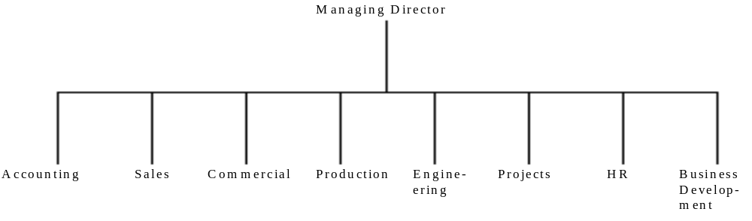

FIGURE 1. Top Level Organisational Chart of HMS.
Next are VSM diagrams created from IS designer’s definition of the purpose of HMS, viz; “A system to produce high quality, finished products that engender customer loyalty thus ensuring future profits from the sale of spare parts.”
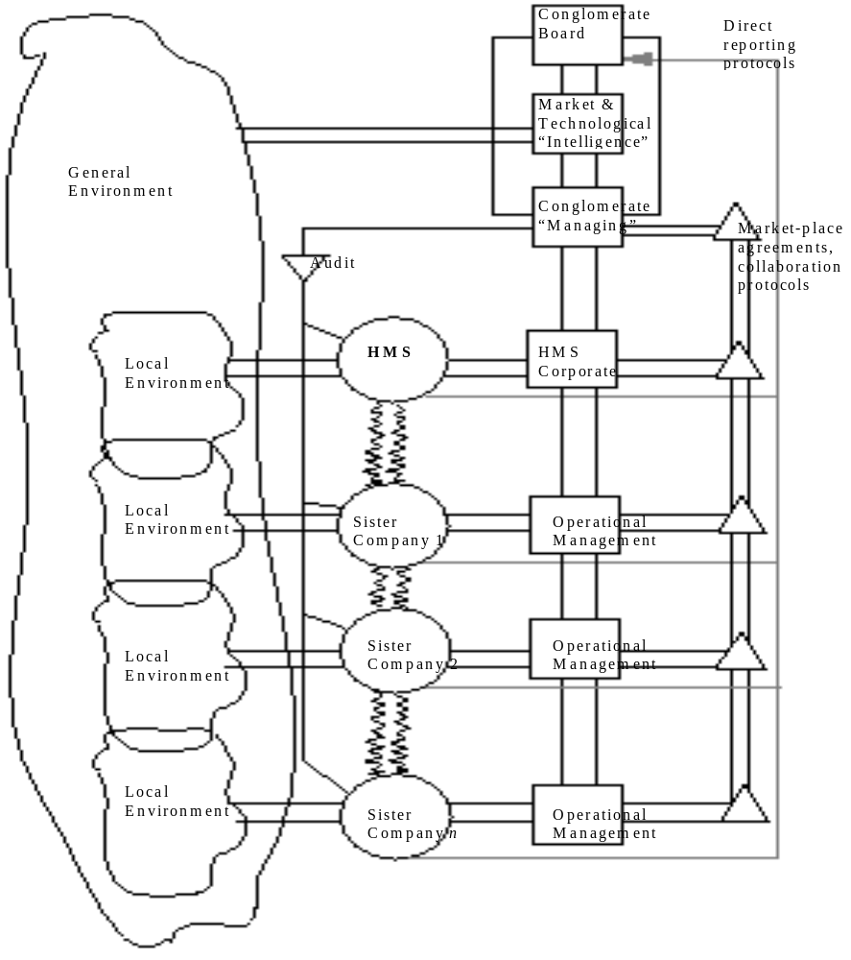

FIGURE 2. Parent Company; Level 0.
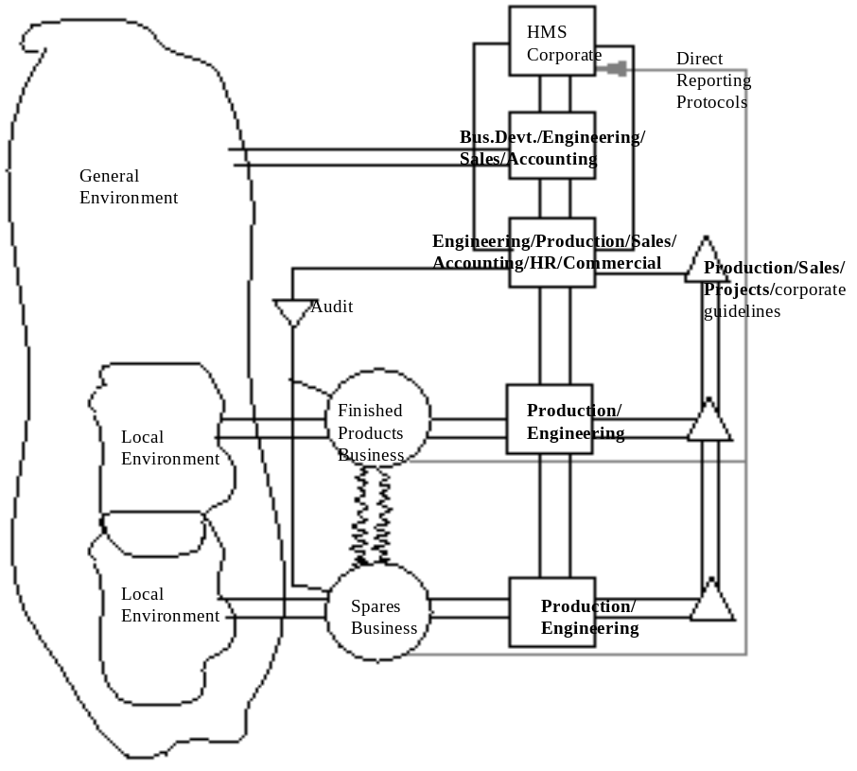

FIGURE 3. Heather Manufacturing Systems; Level 1.

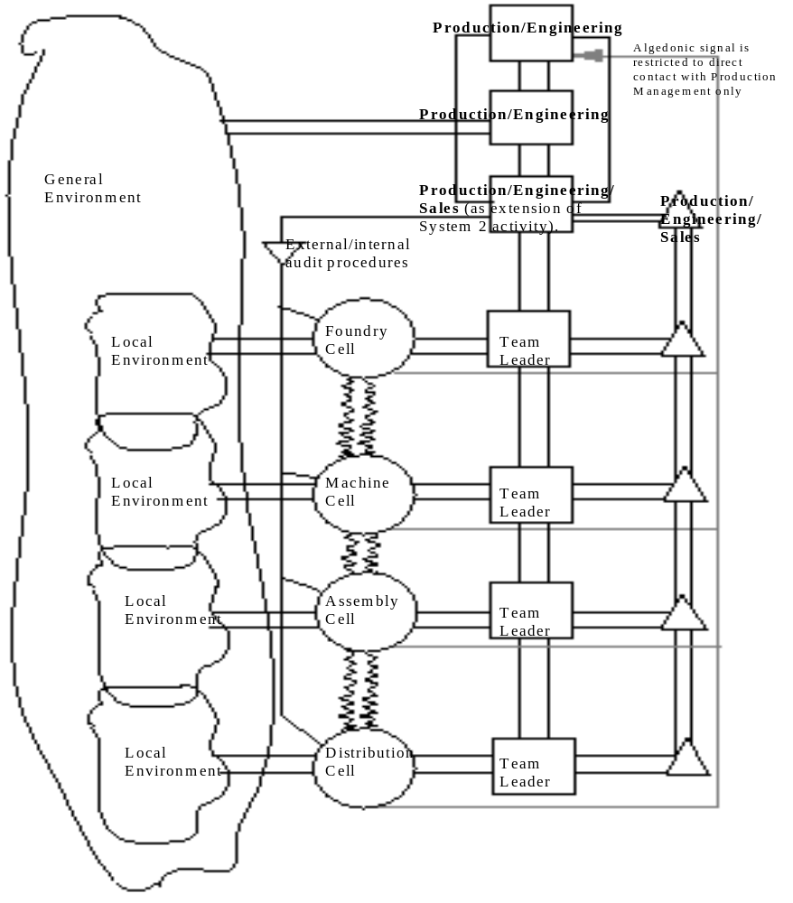
FIGURE 4. Products Business; Level 2.

. Heather Manufacturing Systems (HMS) and Whole Europe Information System for Sales (WEISS) are pseudonyms.

